Satellite Orbit Determination - Assignment 2

Pascal Christiaanse 61017201

## Part A

a) For this question, do not use any of the data in the files. Instead, assume a GPS receiver on an arbitrary satellite in a circular orbit at an altitude of 500 km. Further, assume a GPS transmitter clock error of 0.1 ms and that the GPS satellites are in near-circular orbits with an eccentricity up to 0.01 and a semi-major axis of 26560 km. How large are the following effects on the pseudoranges measured by the GPS receiver?

1) GPS clock offsets **(4 points)**

2) Light time effect **(10 points)**

3) Relativistic effect caused by the eccentricity of the GPS orbits **(6 points)**

Give the approximate size or range of values and explain how you reached that conclusion.

We use c = 299792458.0 m/s

1) The GPS Clock offset can result in an error according to equation below:

2) To answer the light time effect, we assume that: GPS satellite is moving at its maximal velocity -> at pericenter, e=0.01; the satellites are moving in opposite directions; the satellites are lined up (they share a radial unit vector).

3) To determine the error due to relativistic effects we use:

$$v_{gps}=\sqrt{μ\left(\frac{2}{a\left(1-e\right)}-\frac{1}{a}\right)}$$

$$S_{err}=-\frac{2}{c}\left(r*v\right)=-\frac{2}{c}*(a\left(1-e\right)*v_{gps}=686.4 [m]$$

## Part B

b) Now consider the specific case of the GOCE satellite. Inspect file PRN_ID.txt and explain why the PRN IDs change over time. **(5 points)**

There are a total of 32 GPS satellites available in the constellation, however only a certain number of these are in line of sight with GOCE. GOCE is also at a vastly different altitude (lower) and thus overtakes these satellites, thereby changing what satellites are in view. The PRN ID is an identifier code for a specific code, so if the satellite changes so does the code.

## Part C

c) Assume that the pseudorange observations have a standard deviation of 3 m and a correlation of 0.2. Describe how you construct the observation covariance matrix and report the matrix. **(5 points)**

The covariance matrix is an nxn matrix with every cell equal to the product of the correlation factor, the row’s standard deviation and the column’s standard deviation, EXCEPT for the main diagonal, on which the value is the variance or standard deviation squared. N is equal to the amount of observations.

$$c=\begin{matrix}σ_{1}^{2} & & & & \\ ρ*σ_{1}σ_{2} & σ_{2}^{2} & & & \\ ⋮ & & ⋱ & & \\ ρ*σ_{1}σ_{n-1} & & & σ_{n-1}^{2} & \\ ρ*σ_{1}σ_{n} & & & & σ_{n}^{2}\end{matrix}=\left[\begin{matrix}9 & ⋯ & 1.8 \\ ⋮ & ⋱ & ⋮ \\ 1.8 & ⋯ & 9\end{matrix}\right]$$

In this case it turns out to be a matrix with 9 on the main diagonal, and 1.8 on all the off diagonal cells.

## Part D

d) Linearize the observation equation for one pseudo-range observation. The parameters are the GOCE position and the receiver clock offset. Select values for the initial parameter vector that are not zero, i.e., **x**0 ≠ 0. Report the values of the linearised observation equation for the first epoch (vectors **x**0, **f**(**x**0), **y**, and matrix **H**). **(10 points)**

To pick a starting parameter set x0, we pick an arbitrary spot on the earth’s surface, as well as a 1 ms clockoffset:

$$\overline{x}=\begin{matrix}x \\ y \\ z \\ δt\end{matrix}, →{\overline{x}}_{0}=\begin{matrix}6378 [km] \\ 0 \\ 0 \\ 0.001 [s]\end{matrix}$$

We choose the observation equation to be equal to rho:

$$f\left(x_{0}\right)=ρ={\left({\left(x_{0}-x_{gps}\right)}^{2}+{\left(y_{0}-y_{gps}\right)}^{2}+{\left(z_{0}-z_{gps}\right)}^{2}\right)}^{1/2}+c*δt_{0}$$

For the first observation we find f_0(x_0) = 28580.857655560496

From the file ca_range, we read y_0 as

$$y_{0}=[{\begin{matrix}20417.52 & 23357.56 & 18427.07 & 17924.12 & 20548.36 & 18424.96 & 20073.06 & 21451.29 & 19619.59\end{matrix}]}^{T}$$

If we choose the parameters to be the x, y, z position and t the receiver clockoffset, we can construct a state vector.

We find the jacobian for the observation matrix to be the equation below, with A being the information matrix. This row is repeated for each observation.

$$H=\frac{∂A}{∂x ̅}={\left( \begin{matrix}\frac{x-x_{gps}}{{\left({\left(x-x_{gps}\right)}^{2}+{\left(y-y_{gps}\right)}^{2}+{\left(z-z_{gps}\right)}^{2}\right)}^{1/2}} \\ \frac{y-y_{gps}}{{\left({\left(x-x_{gps}\right)}^{2}+{\left(y-y_{gps}\right)}^{2}+{\left(z-z_{gps}\right)}^{2}\right)}^{1/2}} \\ \frac{z-z_{gps}}{{\left({\left(x-x_{gps}\right)}^{2}+{\left(y-y_{gps}\right)}^{2}+{\left(z-z_{gps}\right)}^{2}\right)}^{1/2}} \\ c\end{matrix}\right)}^{T}$$

For the first observation we find

$$H=\begin{matrix}0.345 & 0.921 & 0.105 & 299792\end{matrix}$$

## Part E

e) Implement your code for the least-squares adjustment based on tasks c and d. Use your code to estimate the GOCE positions at all epochs. Include only the corrections for the transmitter and receiver clock offsets in the model for the pseudoranges. Use all pseudorange measurements and consider that the GOCE GPS receiver tracks different GPS satellites over time. In the provided files, the PRN ID is zero when no GPS satellite is tracked. **(20 points)**

Including the transmitter clockoffset improves the position estimate by several orders of magnitude. The jacobian is unchanged, but the observation equation becomes:

$$f\left(x\right)=ρ={\left({\left(x-x_{gps}\right)}^{2}+{\left(y-y_{gps}\right)}^{2}+{\left(z-z_{gps}\right)}^{2}\right)}^{1/2}+c*(δt-δt_{gps})$$

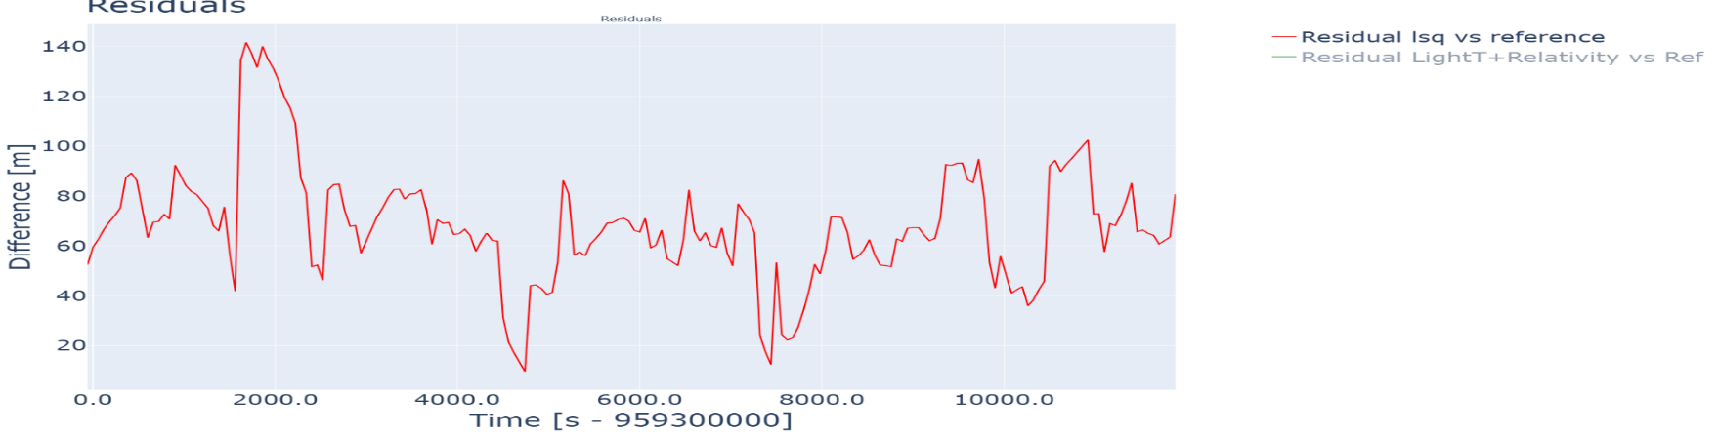

Figure : Norm of residue for position from Receiver and Transmitter clockoffsets

In figure 1, the norm of the difference between the LSQ and reference positions are shown. The maximum difference is 134.85 meters and the minimum is 44.05 meters. Considering lighttime and relativistic effects are not yet taken into account, this is already a very good result.

Table : First four epochs of solution, accounting for Receiver and Transmitter clock offsets

|  |  |  |  |
| --- | --- | --- | --- |
| Time [s] | X [m] | Y [m] | Z [m] |
| 959299940.98 | '849828.57' | -4109915.10 | -5145961.22 |
| 959300000.98 | 816644.54 | -4466750.04 | -4844654.66 |
| 959300060.98 | 776457.28 | -4801499.76 | -4519585.09 |
| 959300120.98 | 729663.00 | -5112476.03 | -4172343.96 |

The iterative solver is stopped when the change in parameters reaches a norm of less than 1e-6, as this provides precision around 1 millimetre. The extra order of magnitude costs around 5 percent in performance but ensures the centimetre precision requirement in the assignment.

## Part F

Do the same as in task e, but now include the light time correction and the correction for relativistic effects. **(14 points)**

Show the difference between your estimated positions and the precise orbit in a figure. Briefly describe the figure. Report the estimated positions for the first four epochs in a table with cm precision.

Show the size of the residuals in the observation equations from tasks e and f. Describe what you show and justify if the change in size is as expected

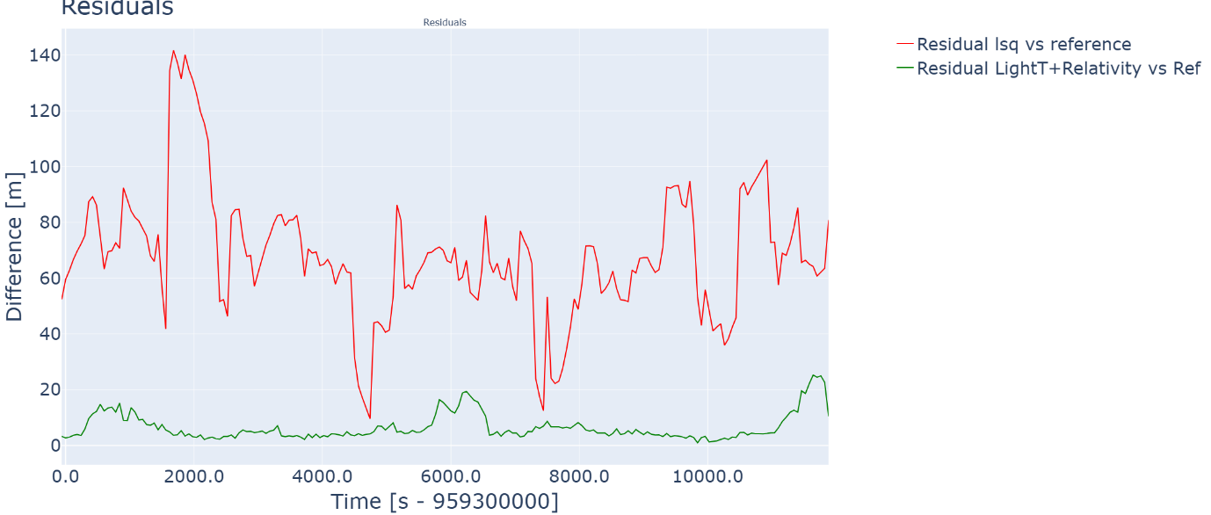

Figure : Residuals for both no corrections and Lighttime plus relativity corrections

Including the lighttime effect introduces a matrix rotation, and an additional term in the clockoffset of the transmitter. This leads us to the following equation:

$$f\left(x,t\right)=ρ_{obs}=|r_{r}(t)-R(ωτ)(r_{t}(t)-τv_{t}(t))|+c*(δt(t)-(δt_{gps}\left(t\right)-\frac{2}{c}(r_{t}^{T}v_{t}))$$

We see that the accuracy is once again improved by around an order of magnitude. The average error is around 5 meters, most likely caused by the neglected ionospheric delay term. The calculated corrections from part A were worst case scenarios, where reality was less punishing. The increase in accuracy is therefore justified.

Table : First four epochs, accounting for clock offsets, lighttime-, and relativistic effects

|  |  |  |  |
| --- | --- | --- | --- |
| Time [s] | X [m] | Y [m] | Z [m] |
| 959299940.98 | 849779.90 | -4109924.63 | -5145958.96 |
| 959300000.98 | 816589.19 | -4466743.02 | -4844642.40 |
| 959300060.98 | 776397.97 | -4801494.93 | -4519577.13 |
| 959300120.98 | 729600.05 | -5112473.00 | -4172339.76 |

## Part G

g) Show the estimated receiver clock offset from task f in a figure. Describe what would happen if we did not model the receiver clock offset in task f. **(12 points)**

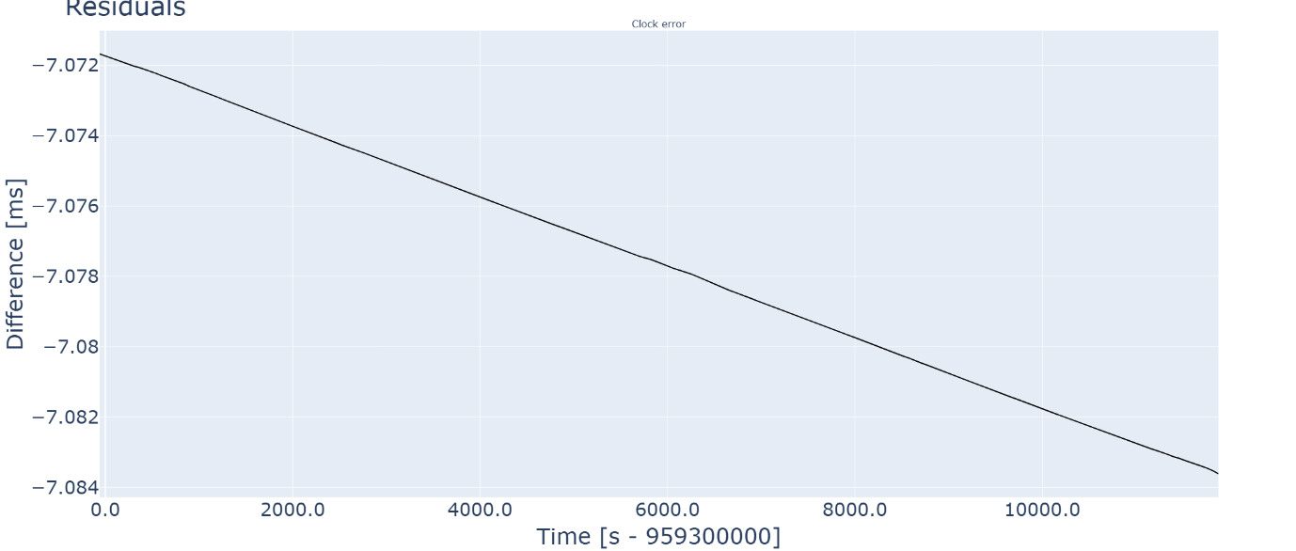

Figure : Receiver clock offset over time for Lighttime plus relativistic solution

As we can see, the receiver clock offset becomes (very slowly) worse with time, and is on average around 7.1 milliseconds behind the reference time. If we did not model this offset, the resulting range equation would be off by 7.1[ms] * c or 21 kilometers.

## Part H

h) For task f, calculate the PDOP values using the equation from the instruction slides. Compare the PDOP values to the difference between your estimated positions and the precise orbit in a figure. Discuss if the size of the PDOP values agrees with the size of the differences and what you can conclude from that, considering task c. **(9 points)**

A priori implying the absence of our solution, we take the variance equal to the standard deviation of our measurements: 3 meters.

$$PDOP=\sqrt{\left(σ_{x}^{2}+σ_{y}^{2}+σ_{z}^{2}\right)}=\sqrt{3*\left(3^{2}\right)}=5.196$$

$$std=σ=\sqrt{\frac{∑\left(| \overline{x_{sol}}-\overline{x_{ref}}|\right)}{n-1}}$$

We calculate the standard deviation of our solution to be 80.96 meters; giving a PDOP of 140.22. We can conclude that our solution is NOT yet optimal and we can still achieve higher position accuracy from our measurements.

## Part I

i) Mention the remaining error/noise sources affecting your solution from task f. Specify and briefly justify their size. Only error and noise sources larger than 10 cm give points. Also, exclude the possibility of mistakes in your solution. **(5 points)**

|  |  |
| --- | --- |
| Source | Error [m] |
| Ionospheric delay | 3-15 meters |
| Offset from COM to receiver | 1 meter |
| Receiver noise | 0.1 meter |

## Time spent

Around 24 hours, I’d say it’s a fair amount of work.